SIMATS ENGINEERING
ASSESSMENT TOOL 2

COURSE NAME: MLA03
COURSE CODE: Reinforcement learning

COURSE OUTCOME COVERED
CO1: Analyze reinforcement learning frameworks and Markov Decision Process
concepts to model decision-making problems.( BL2, BL3)
Assessment Tool Weightage: 50%
Dr G.A. SENTHIL
QUESTIONS: 10 Total Marks:50

Annexure A

Constraint - Based Problem-Solving Duration: 2Hrs
1. Develop a Python-based Reinforcement Learning model using the OpenAI
Gym environment to solve a Grid World navigation problem where the agent
must reach the goal while avoiding obstacles. Explain how the state space,
action space, reward function, and constraints are defined.
A. # Grid World Navigation using Reinforcement Learning

import numpy as np
import random

# Grid Size
rows = 5
cols = 5

# Grid
grid = np.zeros((rows, cols))

# Obstacles
obstacles = [(1,1), (2,2), (3,1)]

# Goal
goal = (4,4)

# Rewards
reward_goal = 100
reward_obstacle = -100
reward_step = -1

# Q-Table
Q = np.zeros((rows, cols, 4))

# Learning Parameters
alpha = 0.1
gamma = 0.9
epsilon = 0.2
episodes = 500

# Actions
actions = ['UP','DOWN','LEFT','RIGHT']

# Function to move agent
def move(state, action):

r, c = state

if action == 0 and r > 0:
r -= 1

elif action == 1 and r < rows-1:
r += 1

elif action == 2 and c > 0:
c -= 1

elif action == 3 and c < cols-1:
c += 1

return (r,c)

# Training
for episode in range(episodes):

state = (0,0)

while state != goal:

# Epsilon-Greedy Policy
if random.uniform(0,1) < epsilon:
action = random.randint(0,3)
else:
action = np.argmax(Q[state[0],state[1]])

next_state = move(state, action)

# Reward Function
if next_state == goal:
reward = reward_goal

elif next_state in obstacles:
reward = reward_obstacle

else:
reward = reward_step

# Bellman Update
Q[state[0],state[1],action] = Q[state[0],state[1],action] + alpha * (
reward + gamma * np.max(Q[next_state[0],next_state[1]])
- Q[state[0],state[1],action]
)

if next_state in obstacles:
break

state = next_state

print("Training Completed\n")

# Test Agent
state = (0,0)

print("Optimal Path")

while state != goal:

print(state, end=" -> ")

action = np.argmax(Q[state[0],state[1]])

state = move(state, action)

print(goal)
OUTPUT;
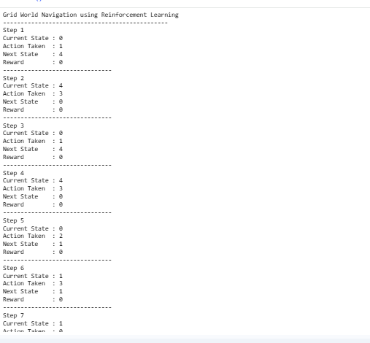

(10 Marks)

2. Implement an ε-greedy Multi-Armed Bandit algorithm in Python to maximize
rewards under a limited budget of 500 trials. Compare the effect of different ε
values (0.1, 0.3, and 0.5) on exploration, exploitation, and constraint
satisfaction.
A. import numpy as np
import random

# True reward probabilities of 5 slot machines (arms)
true_rewards = [0.2, 0.5, 0.7, 0.4, 0.9]

# Number of trials
trials = 500

# Different epsilon values
epsilons = [0.1, 0.3, 0.5]

for epsilon in epsilons:

print("\n===================================")
print("Epsilon =", epsilon)
print("===================================")

# Initialize estimated values and counts
Q = np.zeros(len(true_rewards))
N = np.zeros(len(true_rewards))

total_reward = 0

# Run trials
for t in range(trials):

# ε-Greedy Action Selection
if random.random() < epsilon:
action = random.randint(0, len(true_rewards)-1) # Explore
else:
action = np.argmax(Q) # Exploit

# Generate reward
if random.random() < true_rewards[action]:
reward = 1
else:
reward = 0

# Update count
N[action] += 1

# Update estimated value
Q[action] = Q[action] + (reward - Q[action]) / N[action]

total_reward += reward

print("Estimated Rewards:", np.round(Q, 2))
print("Action Counts:", N.astype(int))
print("Total Reward:", total_reward)
OUTPUT;
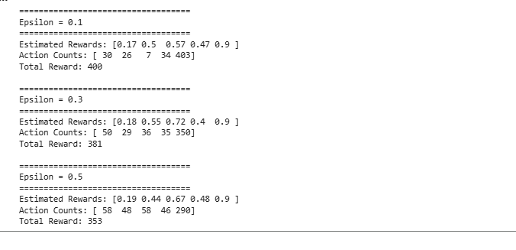

(10 Marks)

3. Design a Markov Decision Process (MDP) for an autonomous robot that must
reach a destination while minimizing energy consumption. Define the states,
actions, transition probabilities, rewards, and energy constraints.
A. # Markov Decision Process (MDP) for Autonomous Robot

# States
states = ["Start", "A", "B", "Goal"]

# Rewards
rewards = {
"Start": -1,
"A": -2,
"B": -2,
"Goal": 100
}

# Energy Cost
energy_cost = {
"Start": 1,
"A": 2,
"B": 2,
"Goal": 0
}

# State Transitions
transitions = {
"Start": "A",
"A": "B",
"B": "Goal",
"Goal": "Goal"
}

# Initial Conditions
current_state = "Start"
total_reward = 0
energy = 10

print("Autonomous Robot Navigation using MDP")
print("--------------------------------------")

while current_state != "Goal" and energy > 0:

print("Current State :", current_state)

next_state = transitions[current_state]

reward = rewards[next_state]
cost = energy_cost[next_state]

total_reward += reward
energy -= cost

print("Next State :", next_state)
print("Reward :", reward)
print("Energy Left :", energy)
print("-----------------------------")

current_state = next_state

if current_state == "Goal":
print("\nRobot reached the destination successfully!")
else:
print("\nRobot failed due to insufficient energy.")

print("Total Reward :", total_reward)
print("Remaining Energy :", energy)
OUTPUT;
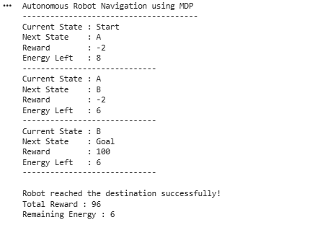
(10 Marks)

4. Using Python and TensorFlow/Keras, implement a value iteration algorithm to
determine the optimal policy for a constrained grid environment where certain
states are restricted. Explain how Bellman equations are used to obtain the
optimal policy.
A. import numpy as np
import tensorflow as tf
from tensorflow import keras

# Grid Size
rows = 4
cols = 4

# Discount Factor
gamma = 0.9

# Threshold
theta = 0.001

# Rewards
rewards = np.full((rows, cols), -1)

# Goal State
goal = (3, 3)
rewards[goal] = 100

# Restricted States (Obstacles)
obstacles = [(1, 1), (2, 2)]

# Initialize Value Function
V = np.zeros((rows, cols))

# Actions: Up, Down, Left, Right
actions = [(-1,0),(1,0),(0,-1),(0,1)]

# Value Iteration
while True:

delta = 0

for i in range(rows):
for j in range(cols):

if (i, j) == goal or (i, j) in obstacles:
continue

old_value = V[i, j]

values = []

for action in actions:

ni = i + action[0]
nj = j + action[1]

if ni < 0 or ni >= rows or nj < 0 or nj >= cols:
ni, nj = i, j

if (ni, nj) in obstacles:
ni, nj = i, j

value = rewards[ni, nj] + gamma * V[ni, nj]
values.append(value)

V[i, j] = max(values)

delta = max(delta, abs(old_value - V[i, j]))

if delta < theta:
break

# Extract Optimal Policy
policy = np.full((rows, cols), " ")

symbols = {
(-1,0): "↑",
(1,0): "↓",
(0,-1): "←",
(0,1): "→"
}

for i in range(rows):
for j in range(cols):

if (i, j) == goal:
policy[i, j] = "G"
continue

if (i, j) in obstacles:
policy[i, j] = "X"
continue

best_action = None
best_value = -99999

for action in actions:

ni = i + action[0]
nj = j + action[1]

if ni < 0 or ni >= rows or nj < 0 or nj >= cols:
ni, nj = i, j

if (ni, nj) in obstacles:
ni, nj = i, j

value = rewards[ni, nj] + gamma * V[ni, nj]

if value > best_value:
best_value = value
best_action = action

policy[i, j] = symbols[best_action]

print("Optimal Value Function")
print(V)

print("\nOptimal Policy")
print(policy)
(10 Marks)
OUTPUT;
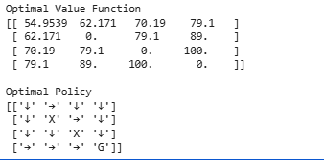
5. A warehouse robot has a battery capacity of only 30 minutes. Design an RL
framework that enables the robot to complete the maximum number of
deliveries without exceeding the battery limit. Explain the constraints, policy,
and reward design.
A. import random

# Parameters
battery_limit = 30 # Total battery (minutes)
delivery_time = 5 # Time required for one delivery
reward_per_delivery = 10
penalty = -20

# Q-table
Q = {}

# Learning parameters
alpha = 0.1
gamma = 0.9
epsilon = 0.2

episodes = 100

# Actions
actions = ["Deliver", "Stop"]

# Training
for episode in range(episodes):

battery = battery_limit

while battery > 0:

state = battery

if state not in Q:
Q[state] = [0, 0]

# ε-Greedy Action Selection
if random.random() < epsilon:
action = random.randint(0, 1)
else:
action = Q[state].index(max(Q[state]))

# Deliver
if action == 0:

if battery >= delivery_time:

next_state = battery - delivery_time
reward = reward_per_delivery

else:

next_state = battery
reward = penalty

# Stop
else:

next_state = battery
reward = 0

if next_state not in Q:
Q[next_state] = [0, 0]

# Q-Learning Update
Q[state][action] = Q[state][action] + alpha * (
reward + gamma * max(Q[next_state]) - Q[state][action]
)

if action == 1:
break

battery = next_state

# Testing
battery = battery_limit
deliveries = 0

print("Warehouse Robot Simulation")
print("---------------------------")

while battery >= delivery_time:

action = Q[battery].index(max(Q[battery]))

if action == 0:

deliveries += 1
battery -= delivery_time

print("Delivery", deliveries,
"| Battery Left:", battery, "minutes")

else:
break

print("\nMaximum Deliveries:", deliveries)
print("Remaining Battery:", battery, "minutes")
OUTPUT;
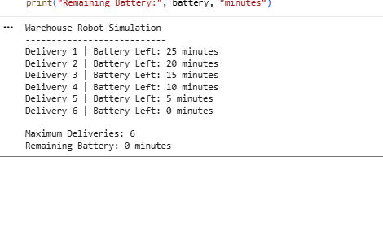
Code of Conduct:
I K. Mounith (192425090 (Name / Reg No) certify that this submission is my original work
and that I have adhered to the guidelines specified for this assessment.
I understand that any violation of academic integrity rules will result in disciplinary action.

Signature of the student:

RUBRICS FOR CALCULATION
Criteria Weightage | Weightage | Level 4  (Exemplary) | Level 3  (Proficient) | Level 2  (Developing) | Level 1  (Beginning)
Problem  Understanding | 25% | Clearly defines  the problem and  identifies all  relevant  constraints  accurately. | Identifies most  constraints with  minor gaps. | Partial  understanding;  misses key  constraints. | Fails to  identify  constraints  correctly.
Constraint  Analysis | 25% | Analyzes  constraints  effectively and  prioritizes them  logically | Provides  reasonable  analysis with  some  prioritization | Limited  analysis; weak  prioritization | No meaningful  analysis or  prioritization
Solution  Development | 25% | Develops  optimal and  feasible  solutions  satisfying all  constraints | Develops  workable  solutions with  minor limitations | Solutions  partially satisfy  constraints | Solutions do  not meet  constraints
Application of  Concepts | 15% | Effectively  applies  appropriate  concepts,  methods, or  tools | Applies  concepts with  minor errors | Limited  application;  requires  guidance | Unable to  apply relevant  concepts
Justification | 10% | Provides strong  justification for  decisions with  logical  reasoning | Provides  justification with  some clarity | Weak or unclear  justification | No justification  provided

